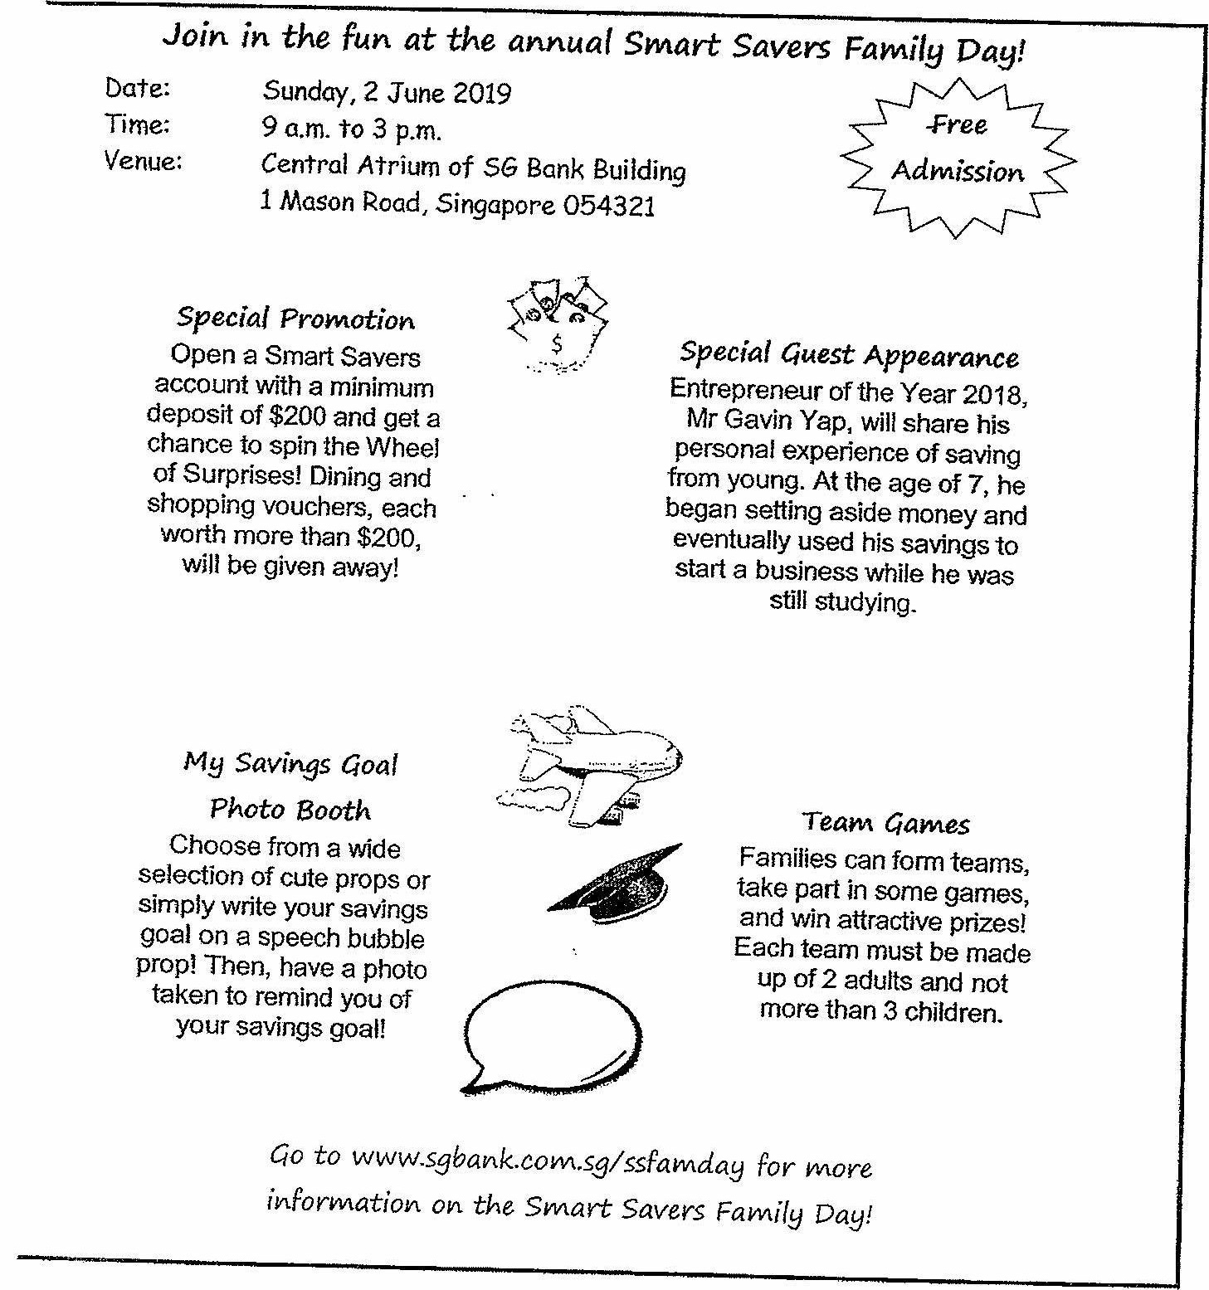

Gc to www.sgbank.com.sg/sstamday for vaore  
information on the Svaart Savers Family Day!